**Lab 13 – IoT**

**Gateway & Machine Learning Report**

# Name: Hasham UL Haq

# Reg-No:22-NTU-CS-1361

# Date: 18-May-2025

# Course: Internet Of Things

# Task 1: Publish DHT Data via MQTT

* Used ESP32 + DHT11 sensor to publish temp & humidity to Mosquitto broker.
* Data sent every second to topics:

o esp32/dht/temp o esp32/dht/hum

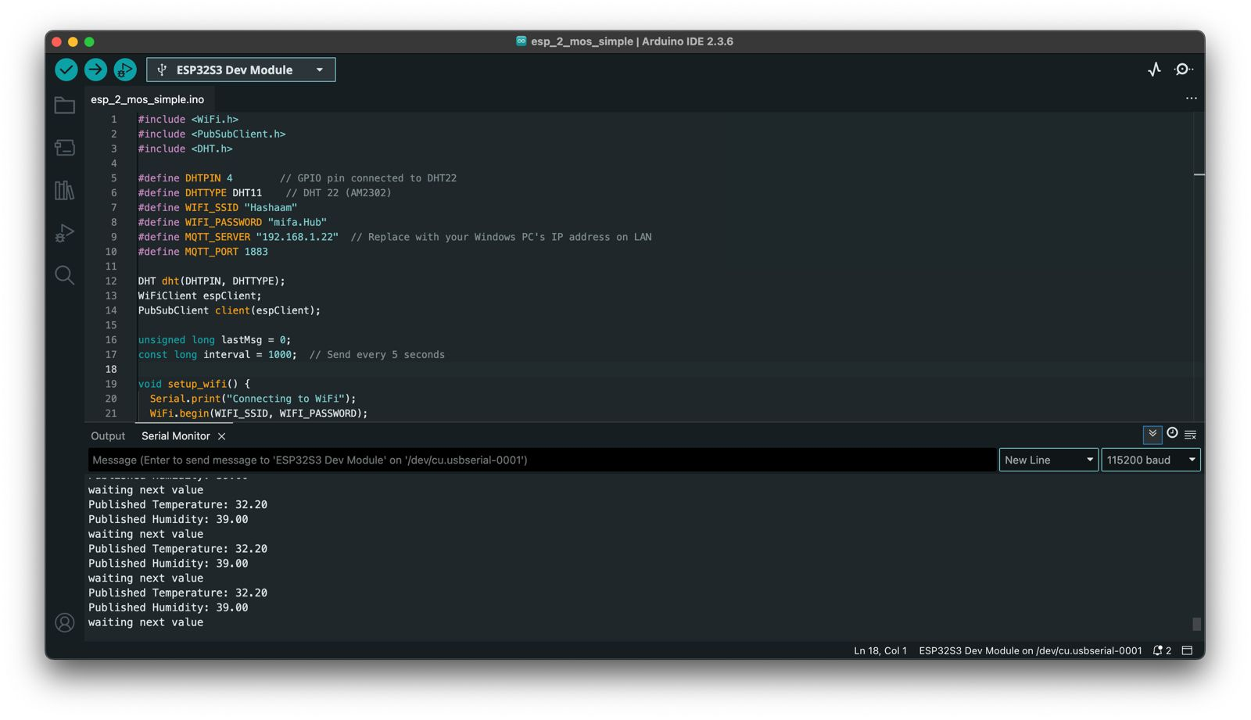

# Task 2: Store MQTT Data in InfluxDB

* Ran 1-dht_data_only.py to subscribe & store MQTT values.
* Connected to InfluxDB bucket (iot_data).
* Verified data using InfluxDB queries.

**MQTT Received:**

* Temp: e.g., 28.5°C
* Humidity: e.g., 36.6%

**InfluxDB:** Service ON  **Query Sample:**

sql

CopyEdit

from(bucket: "iot_data")

|> range(start: -1h)

|> filter(fn: (r) => r._measurement == "dht_data")

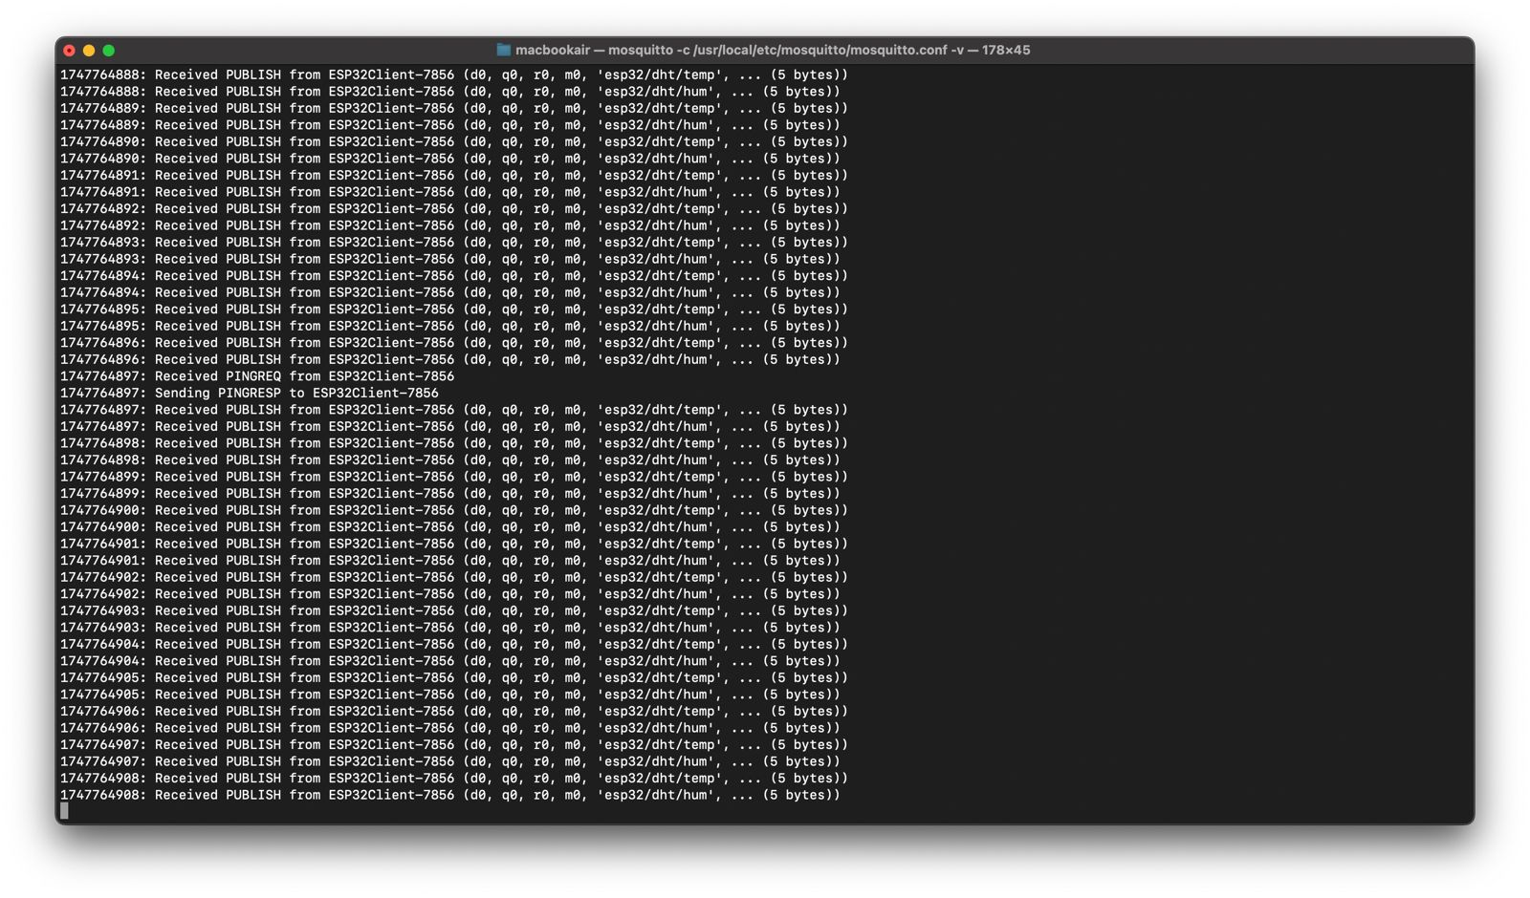

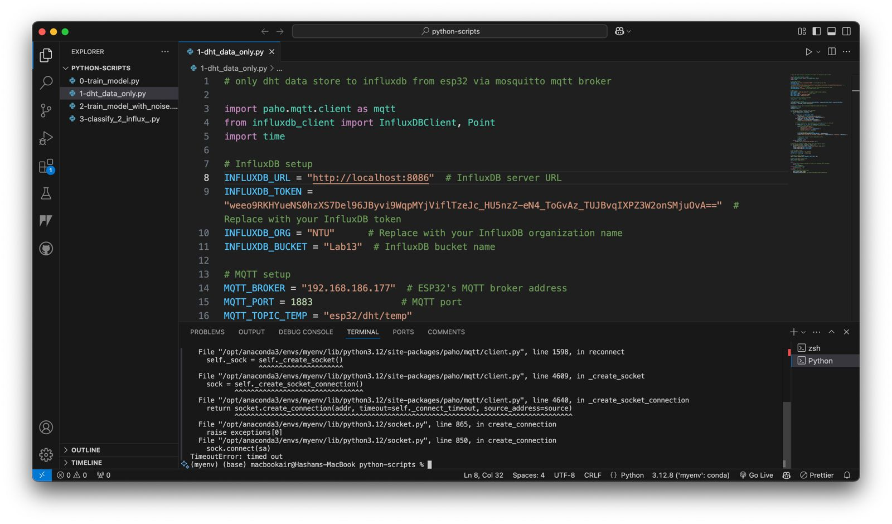

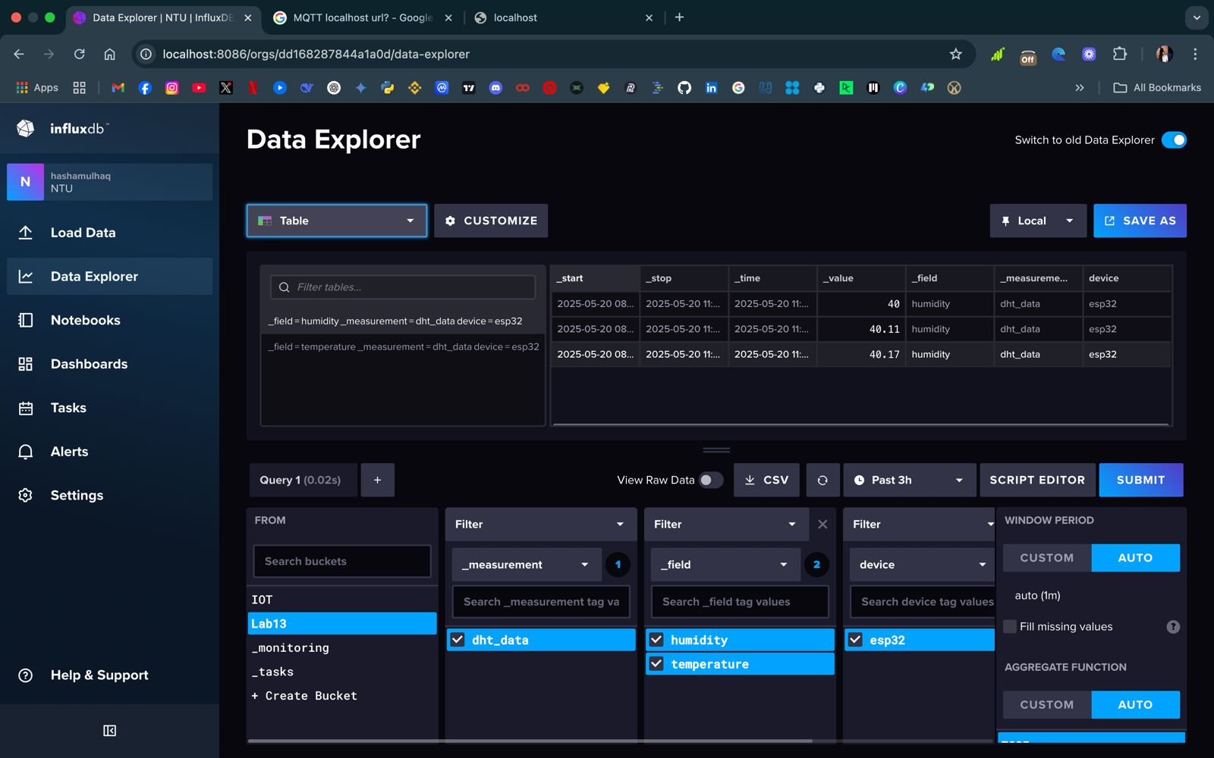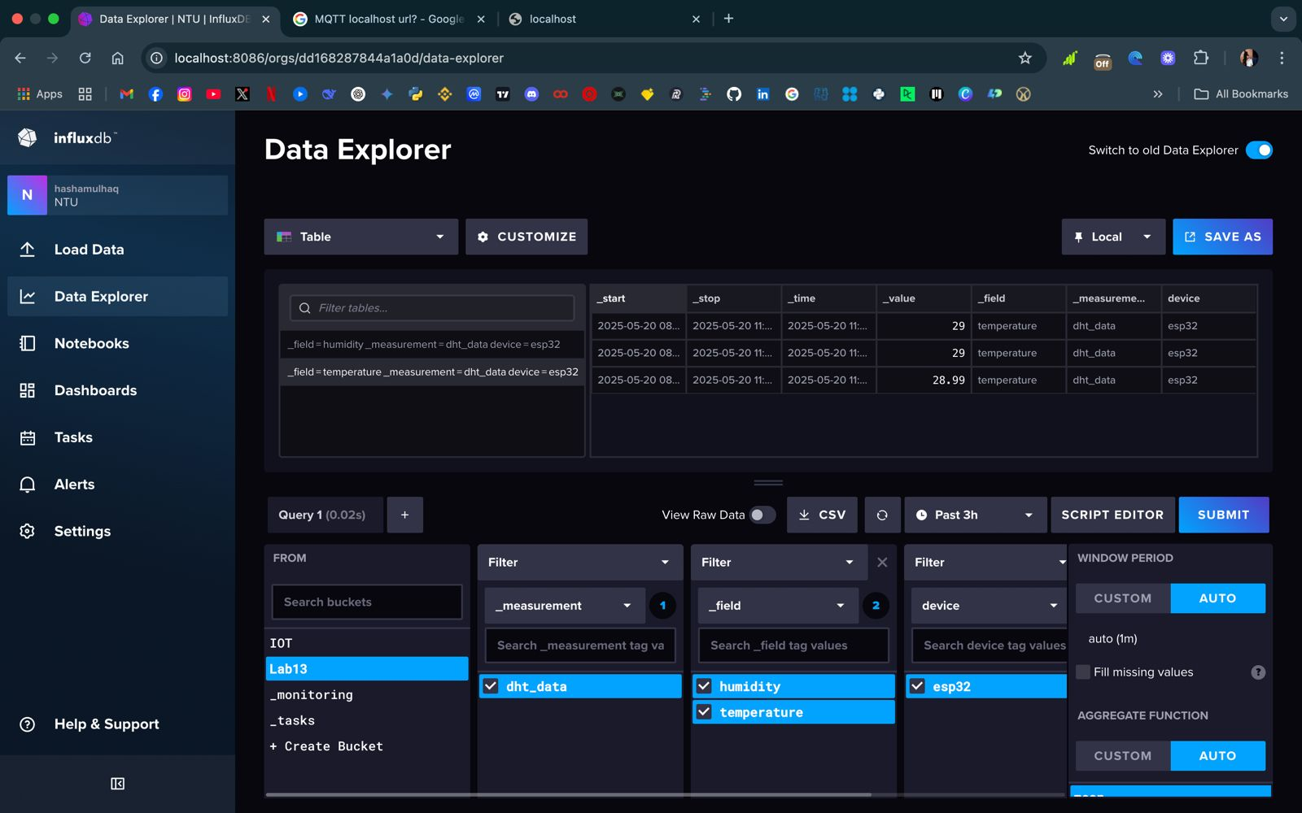

# Task 3: Train ML Model

* Ran 2-train_model_with_noise.py to train classifier.
* Output included a confusion matrix & classification report.

**Accuracy:** ~93%

**Labels:** Low, Normal, High

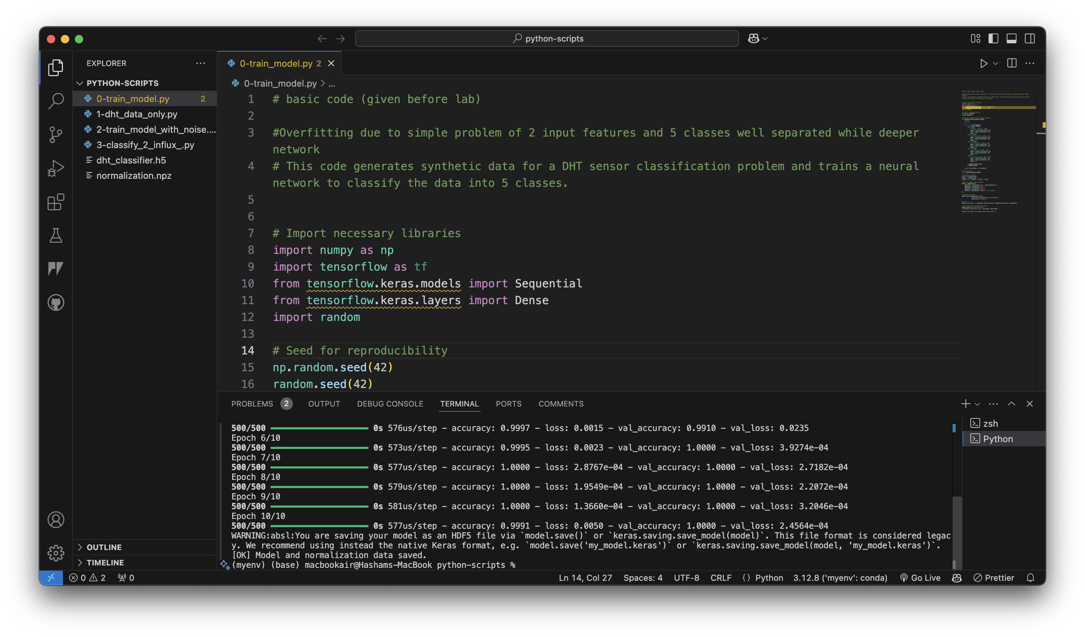

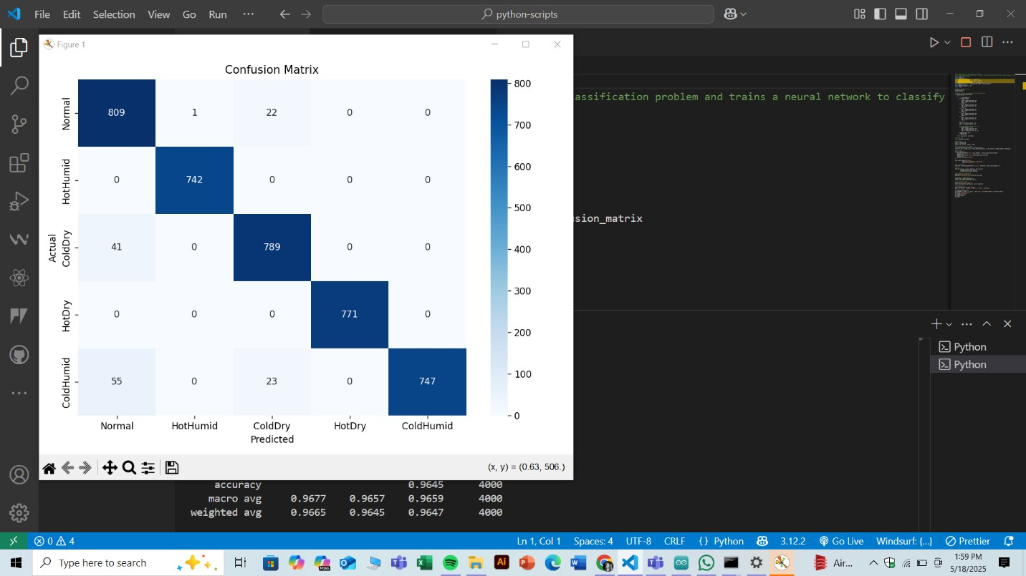

# Task 4: Classify & Store in InfluxDB

* Ran 3-classify_2_influx.py.
* Subscribed to data, used trained model to classify conditions.
* Saved predictions to InfluxDB.

**Query Sample:**

sql

CopyEdit

from(bucket: "iot_data")

|> range(start: -30m)

|> filter(fn: (r) => r._field == "classification")

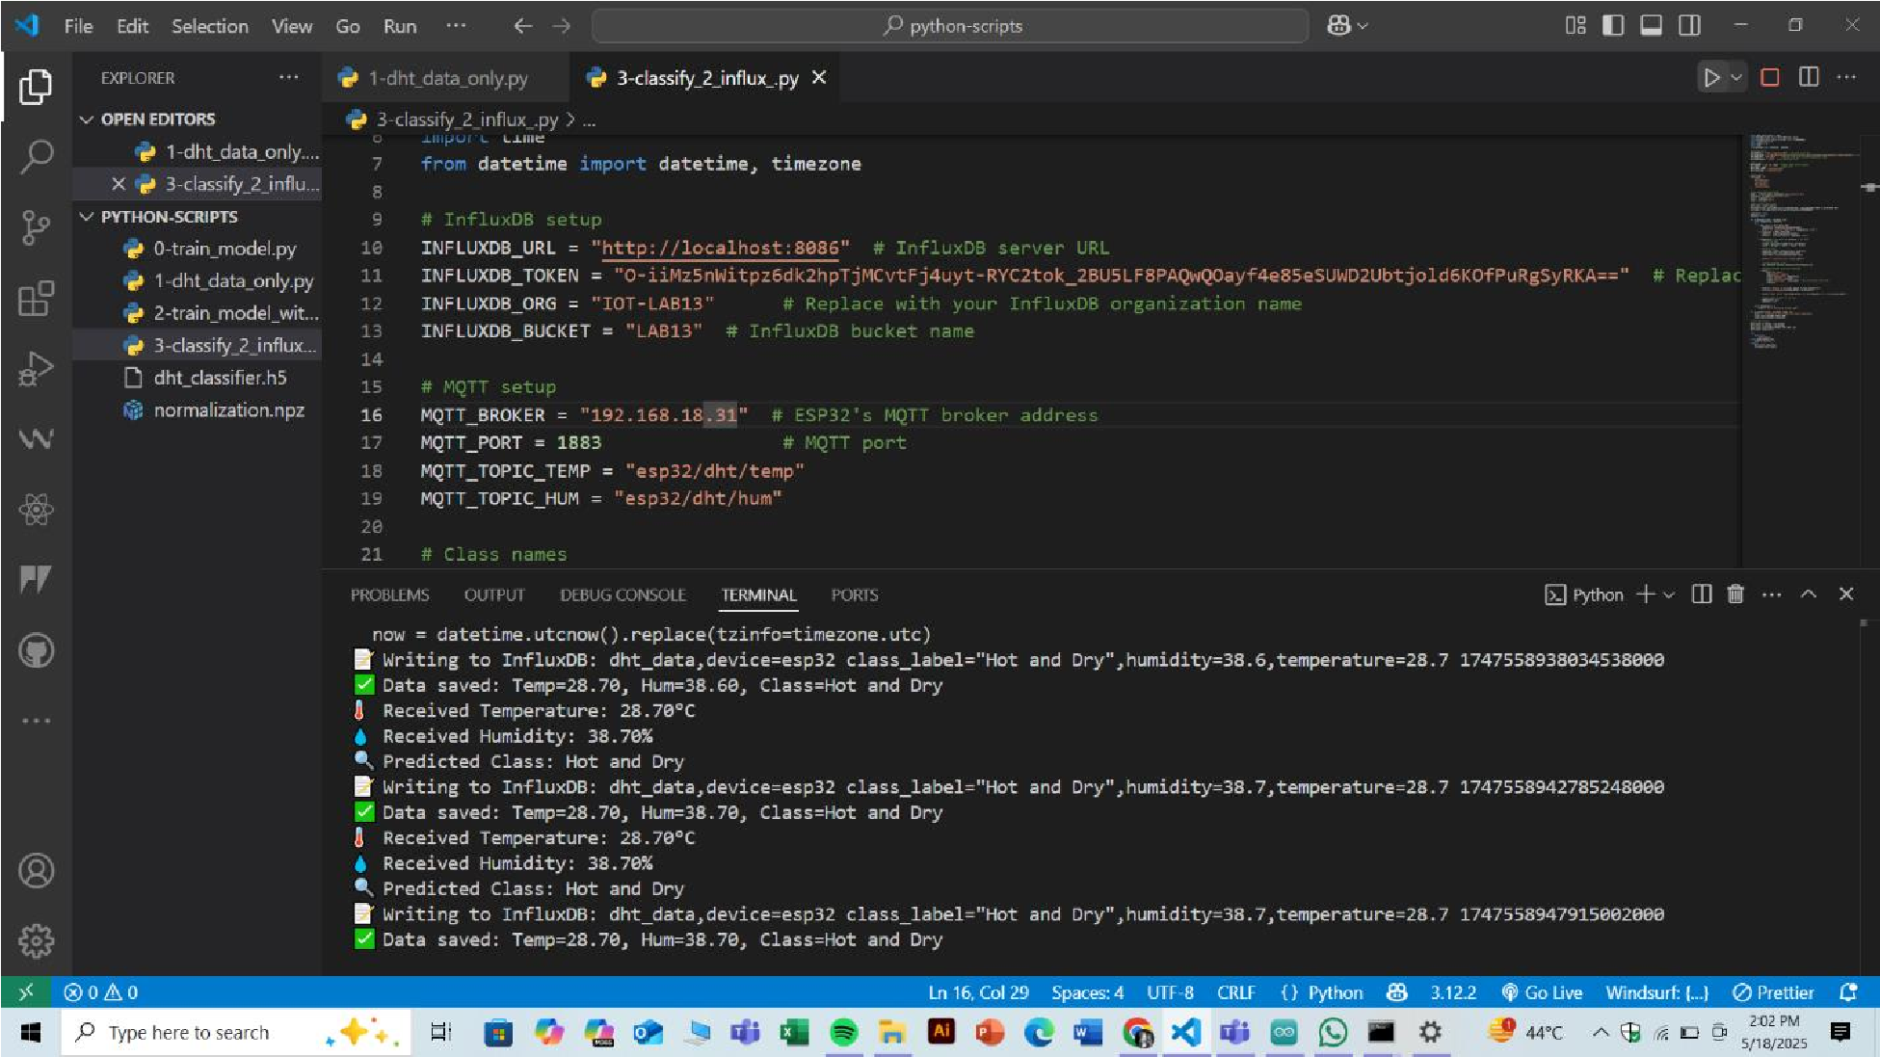

# Challenges Encountered

| Issue | Resolution |
| --- | --- |
| WiFi connection failed | Double-checked SSID and restarted ESP32 |
| MQTT data not arriving | Opened port 1883 in the system firewall |
| No data in InfluxDB | Corrected bucket and measurement names |
| Model performance poor | Minimized noise and retrained the model |

# Conclusion

# Lab 13 was completed successfully. I managed to stream live sensor data from the ESP32 through MQTT into InfluxDB and implemented a machine learning model to classify it. All components were tested and confirmed to work correctly. This lab provided valuable hands-on experience with integrating IoT and AI systems in a practical setting.